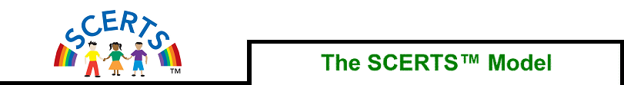

for
Children with Autism Spectrum Disorder

SCERTS developers: Barry Prizant, Amy Wetherby, Emily Rubin, Amy Laurent, Patrick Rydell

S | Social Communication | Helping the child to:  - understand social events  - take part in activities with others  - communicate with others (with words or without words)
C | Social Communication
E | Emotional Regulation | Helping the child to:  - be available for learning  - be actively engaged
R | Emotional Regulation
T | Transactional Supports | - Strategies we use to help the child (e.g. simple language and using visuals)  - Supporting each other to help the child.
S | Transactional Supports

- SCERTS is a framework that we can use to assess a child’s strengths and needs in the areas of social communication and emotional regulation – areas that children with autism have most difficulty in. We can use SCERTS to set goals and monitor a child’s progress.

- From the goals, we plan activities that are meaningful and purposeful, and that can be carried out by all the adults in the child’s life (at home, early childhood setting or school).

- We can plan a balance of free play and structured activities.

- The goals and activities adapted to meet the specific needs of the child based on:
  - Developmental stages of the child
  - Family priorities
  - The child’s motivations and interests

